NAND2Tetris
Implementation of XOR, MUX, and DMUX Gates Using HDL

Name: VASEEM AKRAM
Roll No. : 2501010270
Course: B.Tech CSE
K.R. Mangalam University

Aim: To implement and verify XOR, 2-way MUX, 4-way MUX, and DMUX gates using HDL in the Nand2Tetris Hardware Simulator.

1. XOR Gate-
The XOR gate produces 1 when the two input values are different and 0 when they are the same.
Boolean Expression : OUT = A ⊕ B Expanded Boolean Expression: OUT = (NOT A AND B) OR (A AND NOT B)
Truth Table-
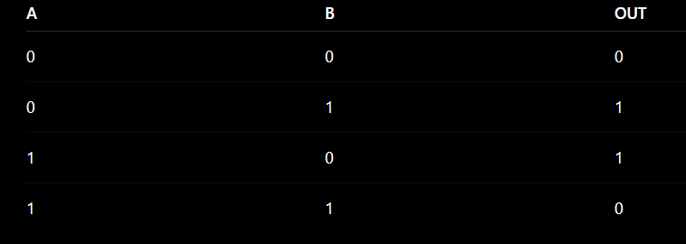
HDL Implementation-
CHIP Xor {
IN a, b;
OUT out;

PARTS:
Nand(a=a, b=a, out=x);
Nand(a=b, b=b, out=y);
Nand(a=a, b=y, out=z);
Nand(a=b, b=x, out=z1);
Nand(a=z, b=z1, out=out);
XOR Gate Simulator Screenshots-
XOR Gate Simulation: a=0, b=0 → out=0 XOR Gate Simulation: a=0, b=1 → out=1
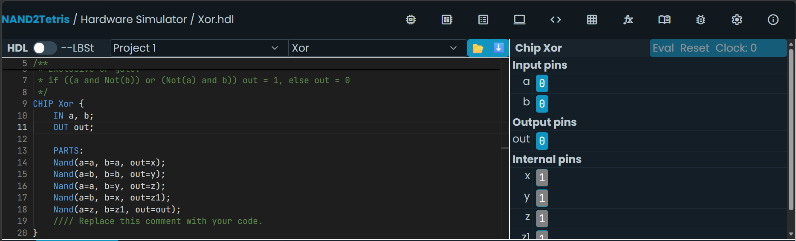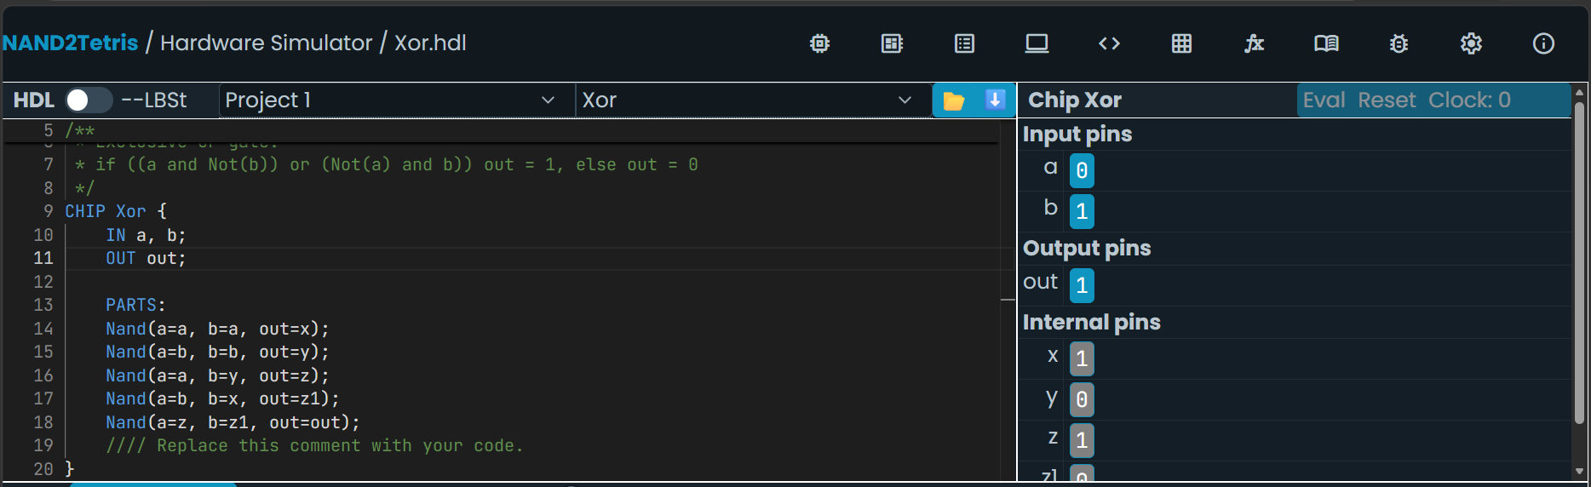
XOR Gate Simulation: a=1, b=0 → out=1 XOR Gate Simulation: a=1, b=1 → out=0
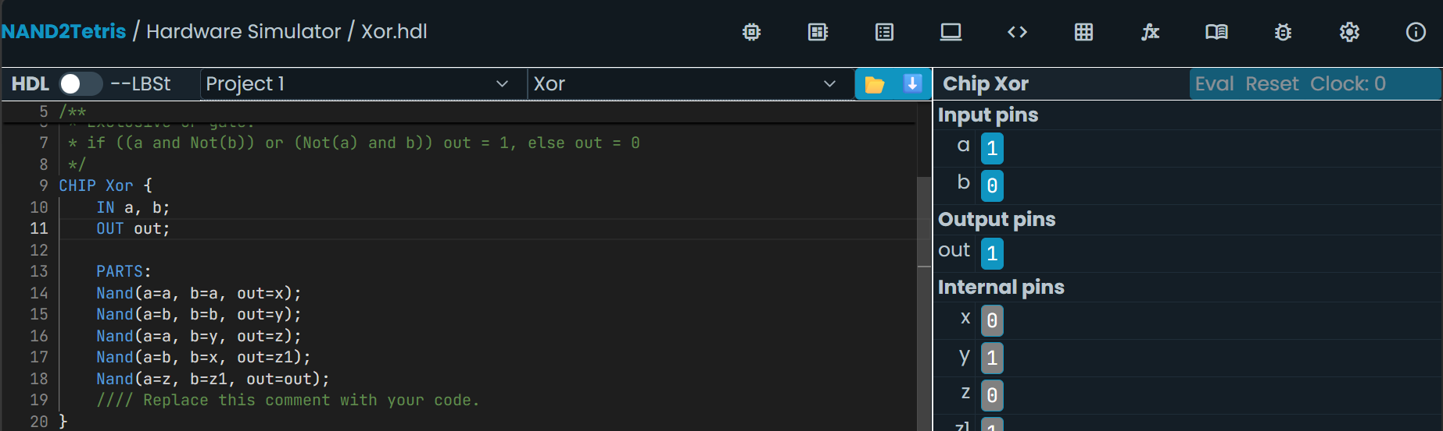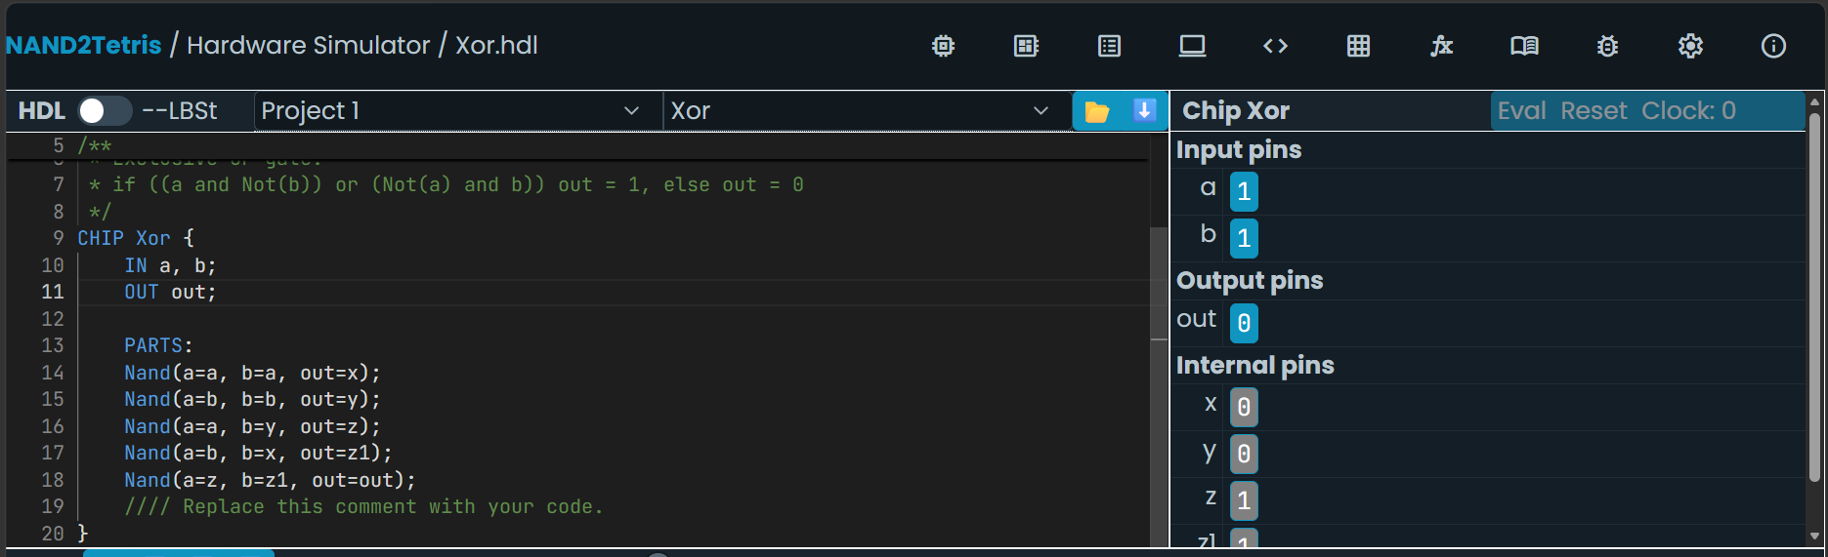

2. MUX (2-Way Multiplexer)-
A 2-way MUX selects one of two inputs (A or B) according to the select signal and sends the selected input to the output.
Boolean Expression : OUT = (NOT SEL AND A) OR (SEL AND B)
Truth Table-
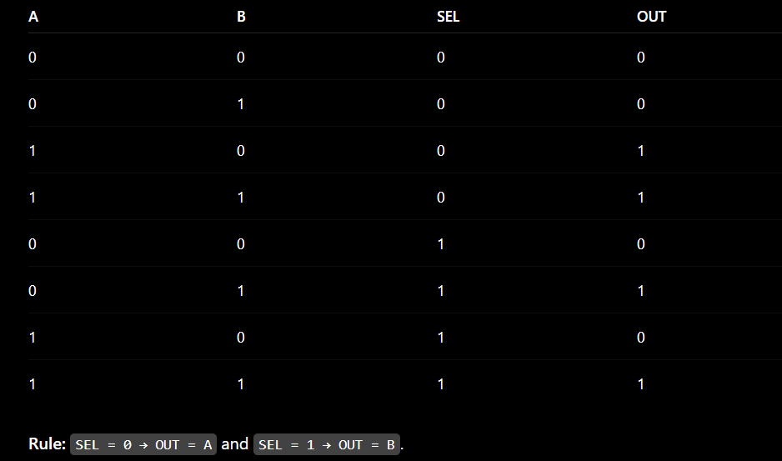
HDL Implementation-
CHIP Mux {
IN a, b, sel;
OUT out;

PARTS:
Not(in=sel, out=nsel);
And(a=nsel, b=a, out=x);
And(a=sel, b=b, out=y);
Or(a=x,b=y, out=out);
MUX (2-Way Multiplexer) Gate Simulator Screenshots-
MUX(2-Way Multiplexer) Gate Simulation: a=0, b=0,sel=0 → out=0 MUX(2-Way Multiplexer) Gate Simulation: a=0, b=1,sel=0 → out=0
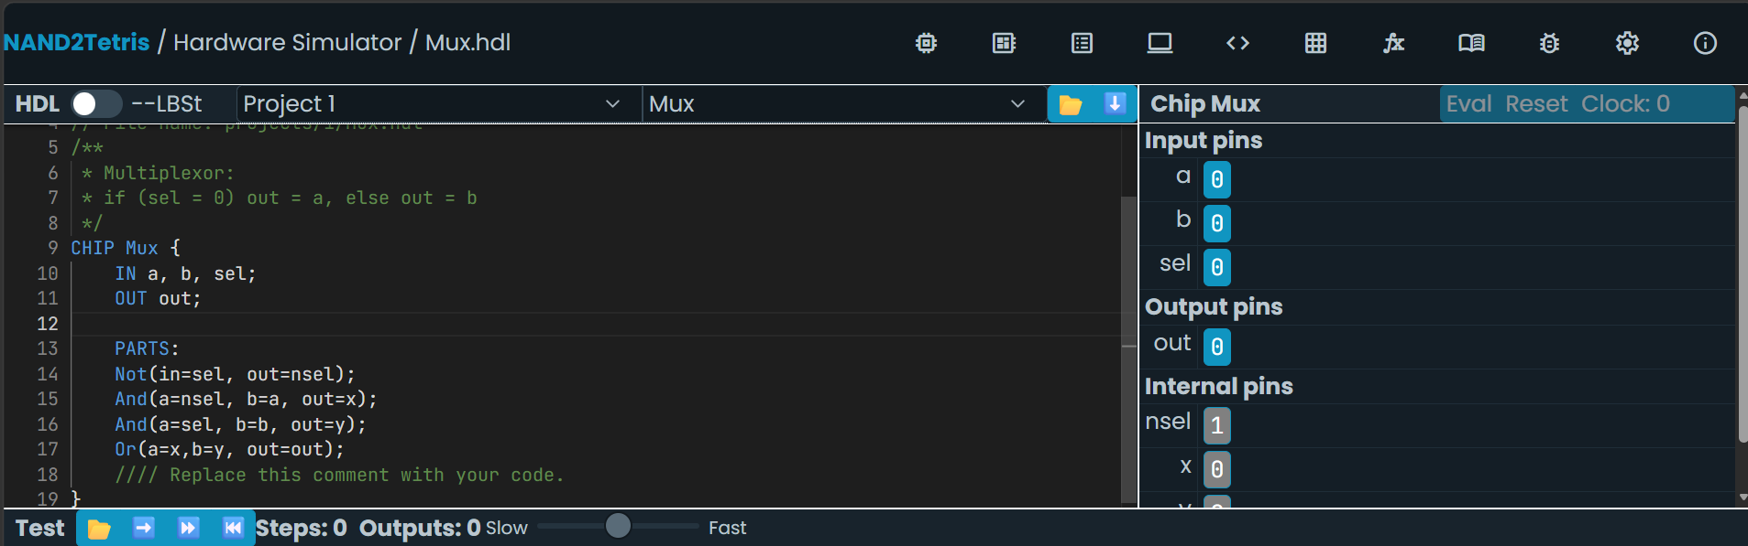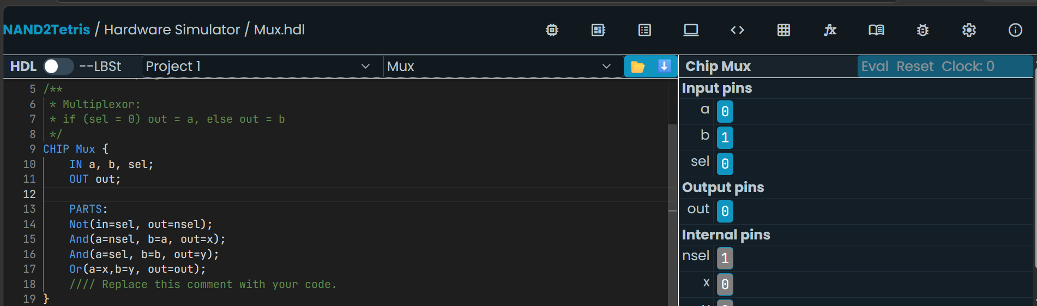
MUX(2-Way Multiplexer) Gate Simulation: a=1, b=0,sel=0 → out=1 MUX(2-Way Multiplexer) Gate Simulation: a=1, b=1,sel=0 → out=1
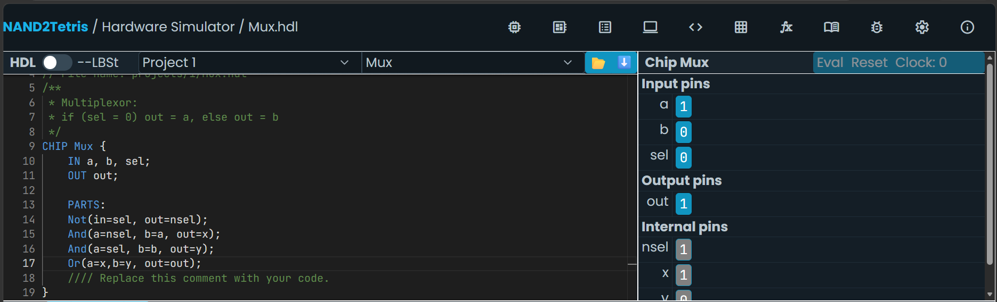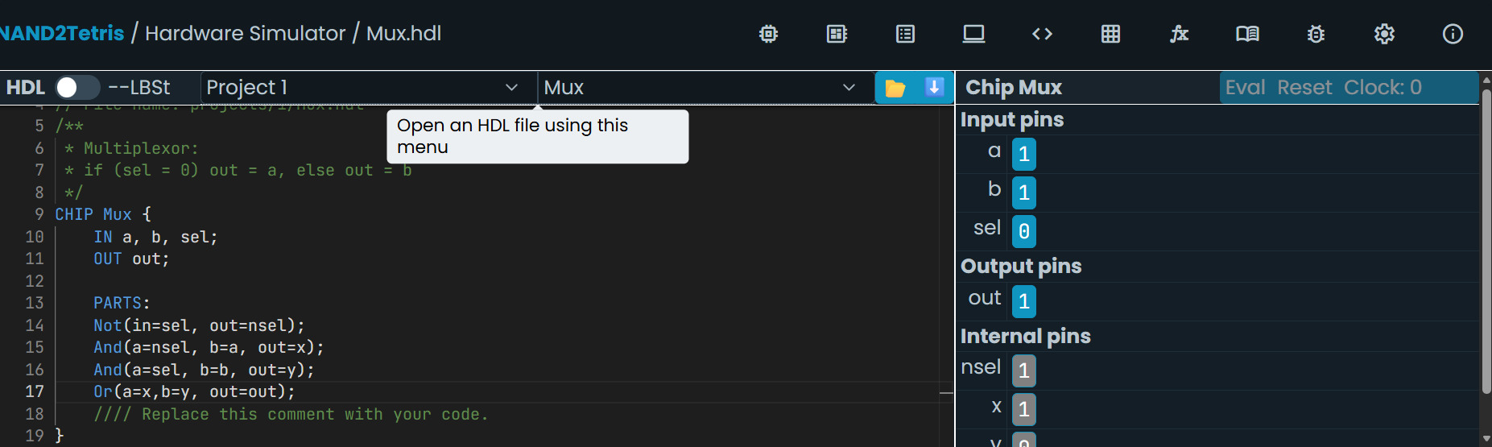
MUX(2-Way Multiplexer) Gate Simulation: a=0, b=0,sel=1 → out=0 MUX(2-Way Multiplexer) Gate Simulation: a=0, b=1,sel=1 → out=1
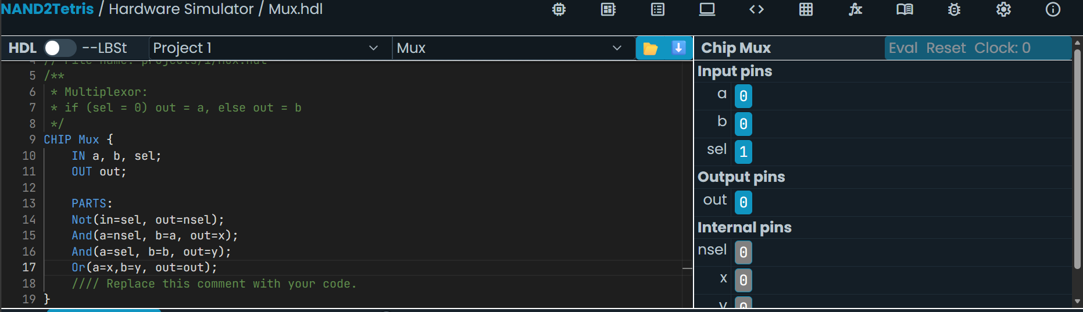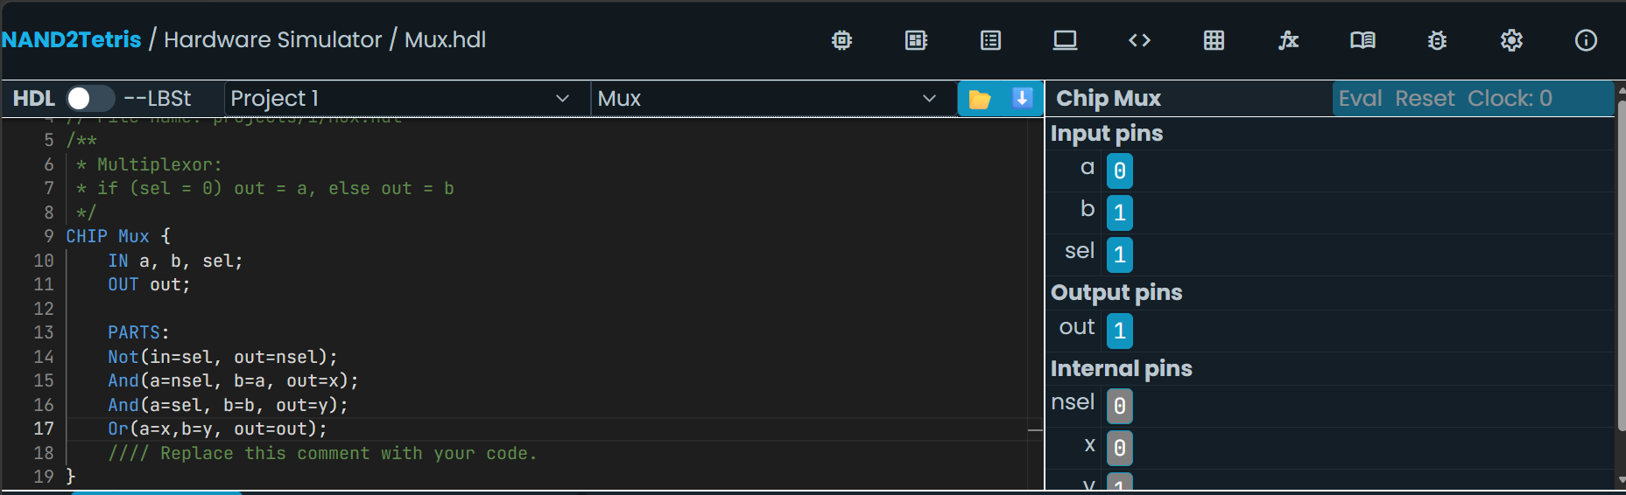
MUX(2-Way Multiplexer) Gate Simulation: a=1, b=0,sel=1 → out=0 MUX(2-Way Multiplexer) Gate Simulation: a=1, b=1,sel=1 → out=1
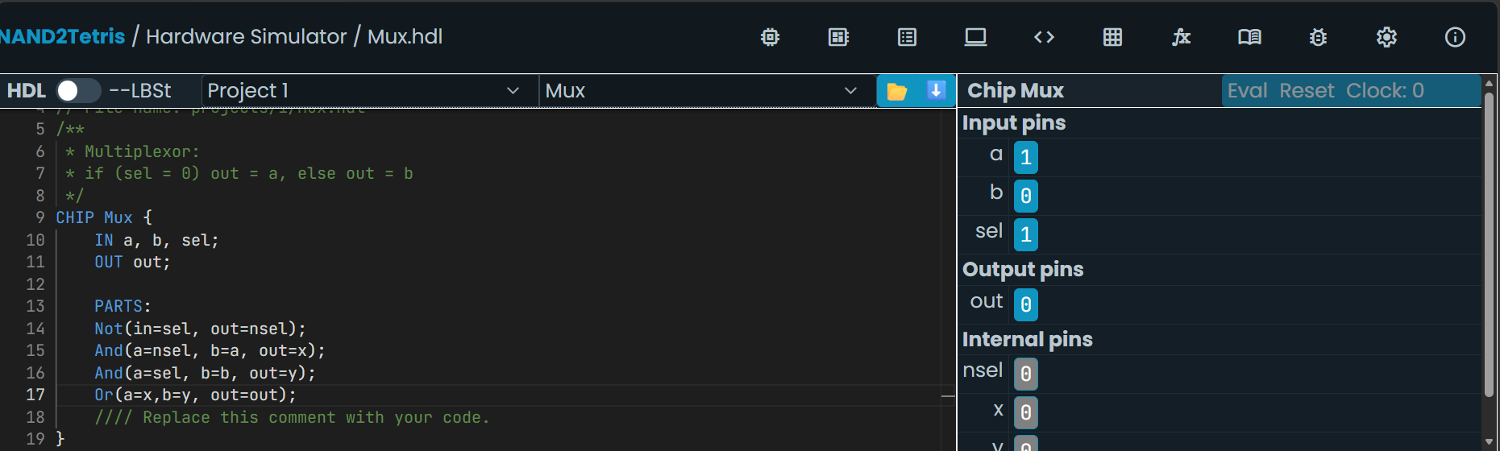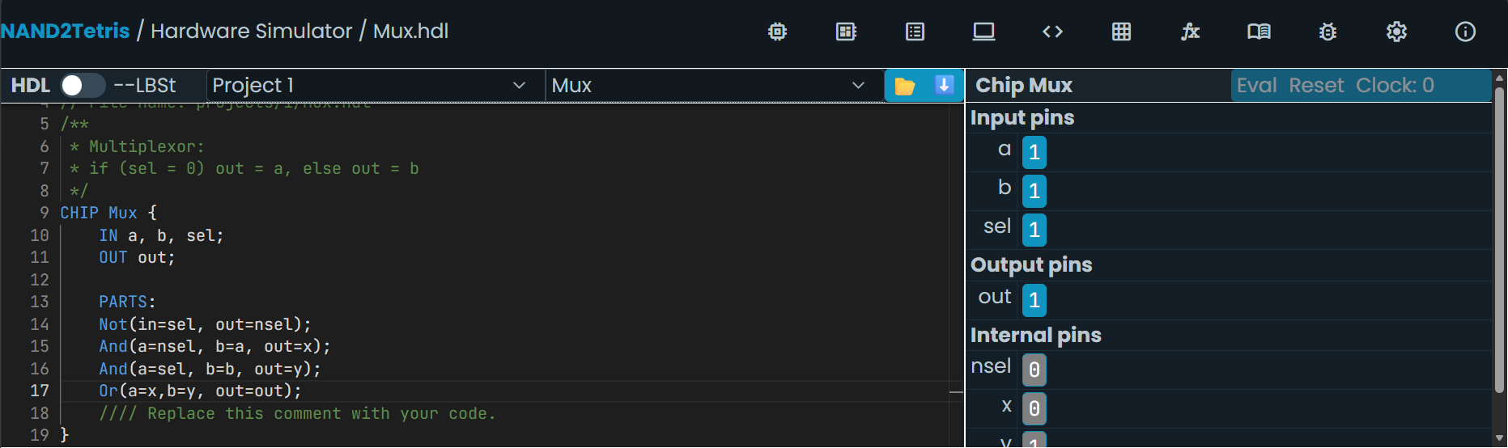

3. 2-Bit MUX (Mux16-style)-
A 2-bit MUX selects one of two 2-bit input buses using the select signal and transfers the selected bus to the output.
Boolean Expression : OUT[i] = (NOT SEL AND A[i]) OR (SEL AND B[i])
Truth Table-
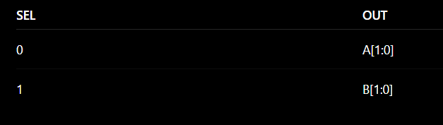
HDL Implementation-

2-Bit MUX(MUX16-style) Gate Simulator Screenshots-

4. 4-Way MUX-
A 4-way MUX selects one of four input values using two select bits and passes the selected input to the output..
Boolean Expression : OUT = (NOT SEL1 AND NOT SEL0 AND A) OR (NOT SEL1 AND SEL0 AND B) OR (SEL1 AND NOT SEL0 AND C) OR (SEL1 AND SEL0 AND D)
Truth Table-
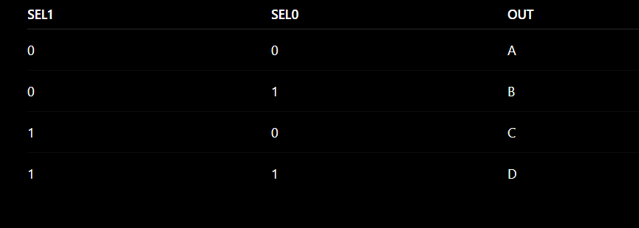
HDL Implementation-
4-Way MUX Gate Simulator Screenshots-

5. DMUX (Demultiplexer)-
A DMUX takes one input and routes it to one of two outputs according to the select signal, while the other output remains 0.
Boolean Expression : A = IN AND NOT SEL
B = IN AND SEL
Truth Table-


